Project Design Phase-II
Data Flow Diagram & User Stories
Date: | 26-12-2025
Team ID:
Project Name: | Book a Doctor – Online Doctor Appointment System
Maximum Marks: | 4 Marks

Data Flow Diagrams:
A Data Flow Diagram (DFD) illustrates how data moves within the Book a Doctor system. It represents how users (patients), doctors, and administrators interact with the platform, how appointment requests, user profiles, and medical documents flow between different system components, and how this information is securely stored and retrieved from the database.
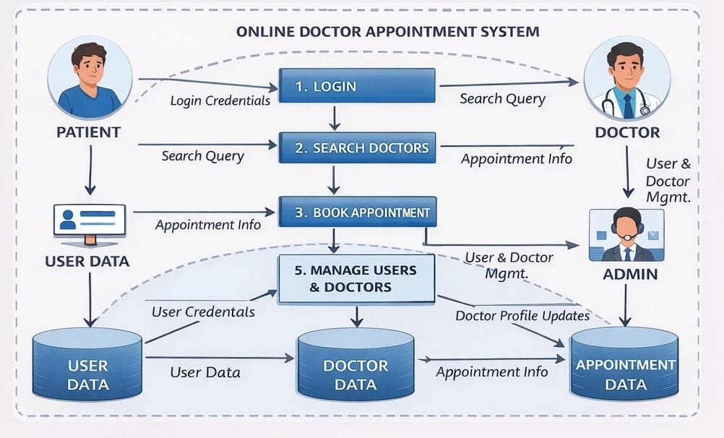
User Stories
User Story Table – Book a Doctor
User Type | Functional Requirement (Epic) | User Story / Task |  | Priority
  Acceptance Criteria
  Release
User (Patient) | Doctor Search & Viewing | As a user, I want to view and browse available doctors. | Doctor list is displayed with specialization and availability. | High | Sprint-1
 | Appointment Booking | As a user, I want to book an appointment with a doctor by selecting date and time. | Appointment is successfully created and shown in my dashboard. | High | Sprint-1
  User (Patient)
User (Patient) |  | As a user, I want to upload medical documents while booking an appointment. | Document is uploaded and visible to the doctor. | Medium | Sprint-1
  Document Upload
Doctor |  | As a doctor, I want to approve or reject appointment requests. | Appointment status updates correctly for the user. | High
  Appointment Management
  Sprint-1
 | Appointment Completion | As a doctor, I want to mark approved appointments as completed. | Appointment status changes to completed and is saved.
  Doctor
  Medium
  Sprint-2
User (Patient) |  | As a user, I want to view my appointment history and status. | All past and active appointments are displayed accurately.
  Appointment Tracking
  Medium
  Sprint-2
Admin | Doctor Approval | As an admin, I want to approve or reject doctor registration requests. | Doctor status updates and reflects across the platform. | High | Sprint-1
Admin |  | As an admin, I want to view and manage all users and doctors. | Users and doctors are listed with correct details. | High | Sprint-1
  User & Doctor Management
Admin | Appointment Monitoring | As an admin, I want to view all appointments in the system. | All appointments are visible with user and doctor details. |  | Sprint-2
  Medium

